info BC – Fitness & Pool key card receipt

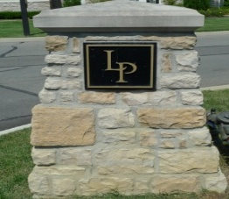
LAKES AT POLARIS CONDOMINIUM ASSOCIATION
c/o Sentry Management, Inc.
4249 Easton Way, Suite 220
Columbus OH 43219
800-932-6636
columbus@sentrymgt.com

I, _________________________________, HEREBY ACKNOWLEDGE THAT I HAVE RECEIVED A FITNESS ROOM AND POOL KEY FOR LAKES AT POLARIS CONDOMINIUM ASSOCIATION.

___________________________________________________________
Please Print Unit Owner Name & Unit Address

SIGNED THIS DAY OF 2025

BY:

(Signature of Unit Owner)

Replacement cost is $50.00 - please mail check prior to release of keycard

Checks to be made out to Lakes at Polaris Condominium Association

KEY # __________________________________________

