info Document AI – Patio Extension Specifications & RFA

The following specifications must be followed for the construction of a first-floor patio extension. No other options are permitted to ensure harmony throughout the community. There are size options, but no deviation from stone work or color. The LAP condominium Board of Directors has approved this specification only, for any patio extension to be installed.
The LAP Board of Directors is not required to approve a patio extension request. The request may be declined due to underground utilities, insufficient space to build, right of ways, or other requirements. A Board member will review the proposed patio site prior to construction, during construction, and after construction. Any deviation from the specifications will need to be corrected to the satisfaction of the Board of Directors.
A Request for Alteration is required, as well as, a signed copy of the included agreement with the LAP Condominium Association which grants a “temporary” installation of a patio extension. Should a future owner not want the patio, the current owner must remove it and restore the CE to its original condition. Since the installation of a patio at Lakes at Polaris is considered “temporary” a construction permit should not be required.
Note: No structural changes to the LAP Condominium buildings are allowed per the bylaws therefore this specification only applies to first-floor Condominium Units.

A suggested mason who only does patios and has excellent ratings, reasonable prices, and will install on time, and has special pricing for LAP is:
Email: dwoodrum.dlg@gmail.com
DLG Property Services LLC
Mount Gilead, OH
Mon-SAT: 8 AM to 8 PM
Web site: https://www.dlgpropertyservices.com
What you will find about Danny Woodrum’s company:
- Very reasonable pricing based on other vender quotes
- Personable and accommodating
- BBB A+
- 5-star reviews
- All-inclusive price and repairs any lawn damage, with new top soil and seeding
- Great references
- Completed work pictures
- Patio warrantied for 3 years

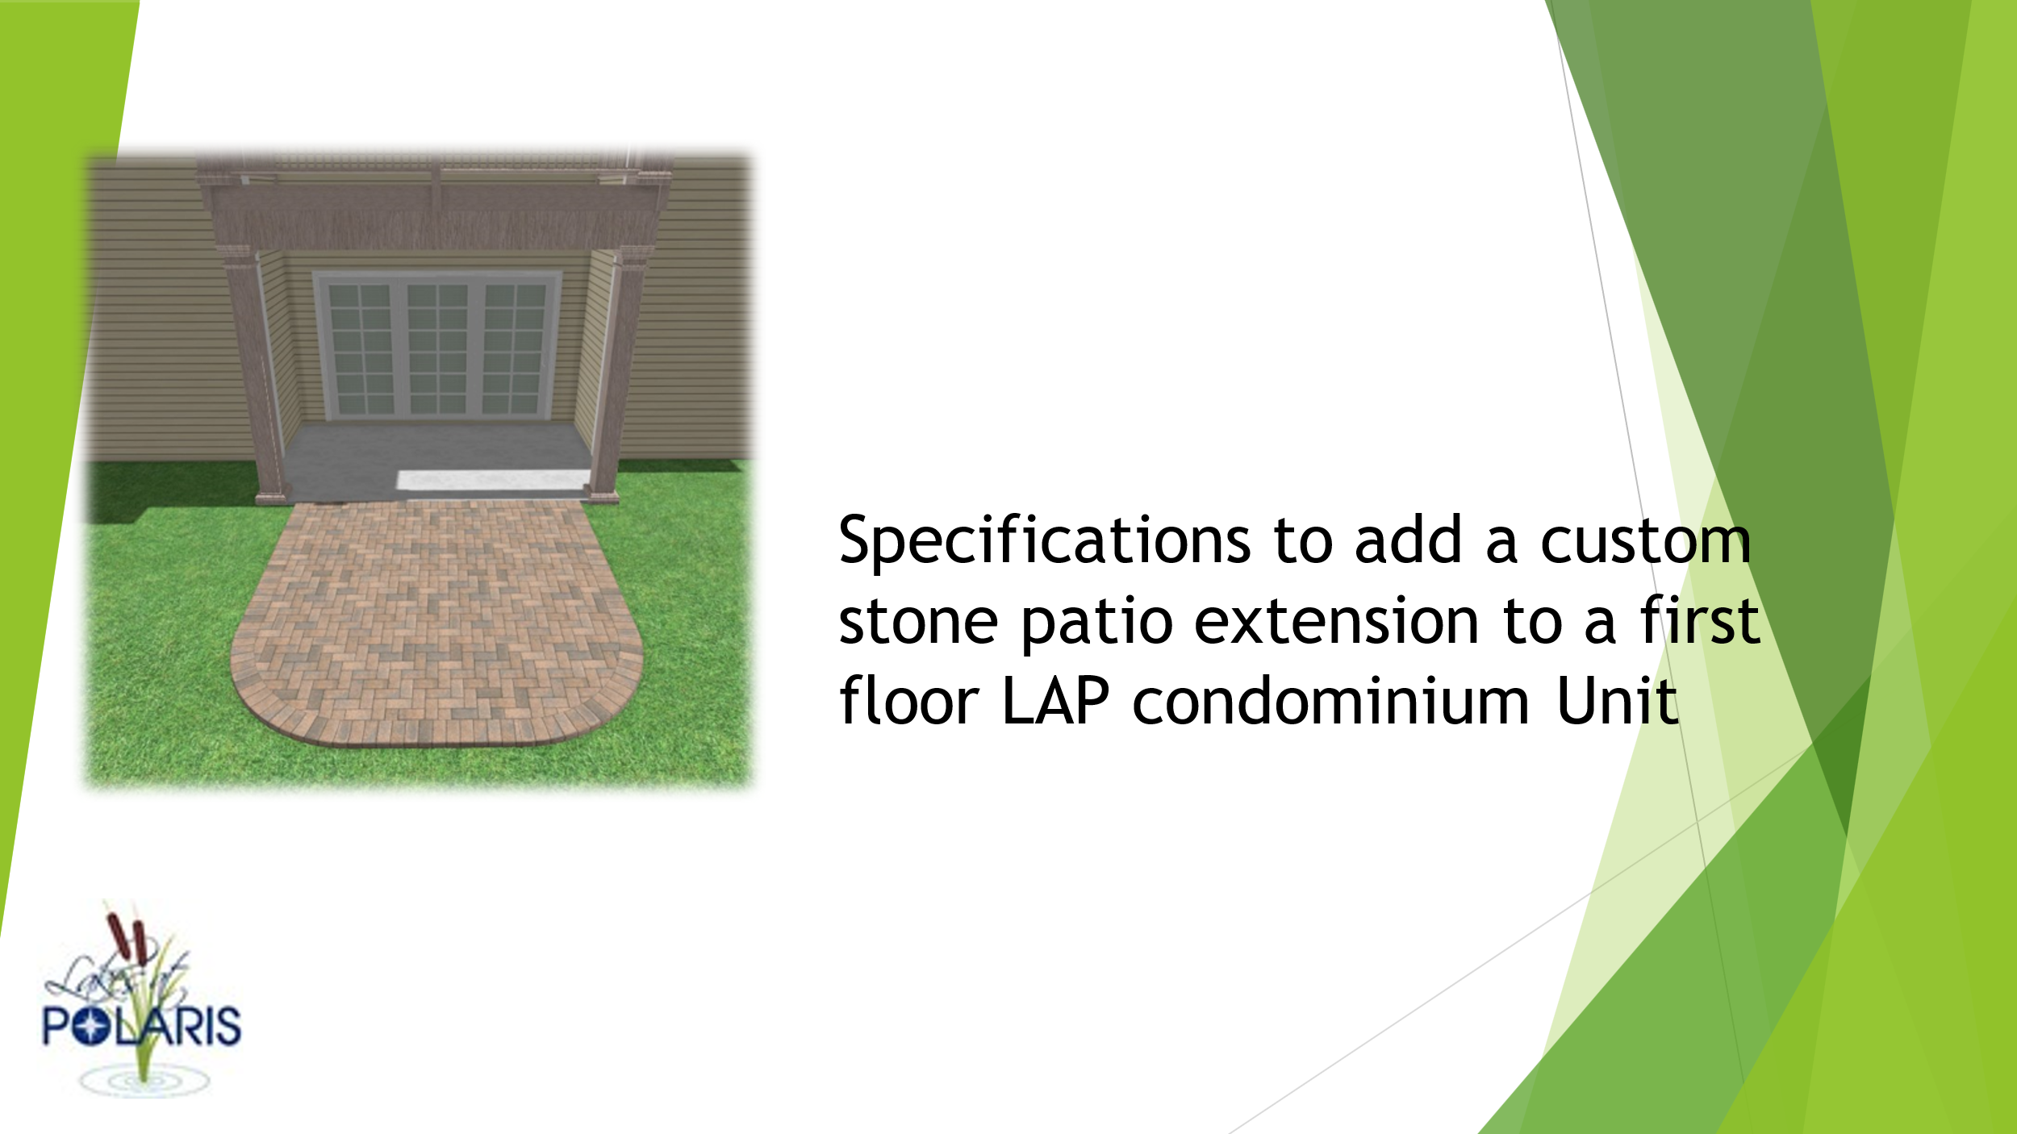

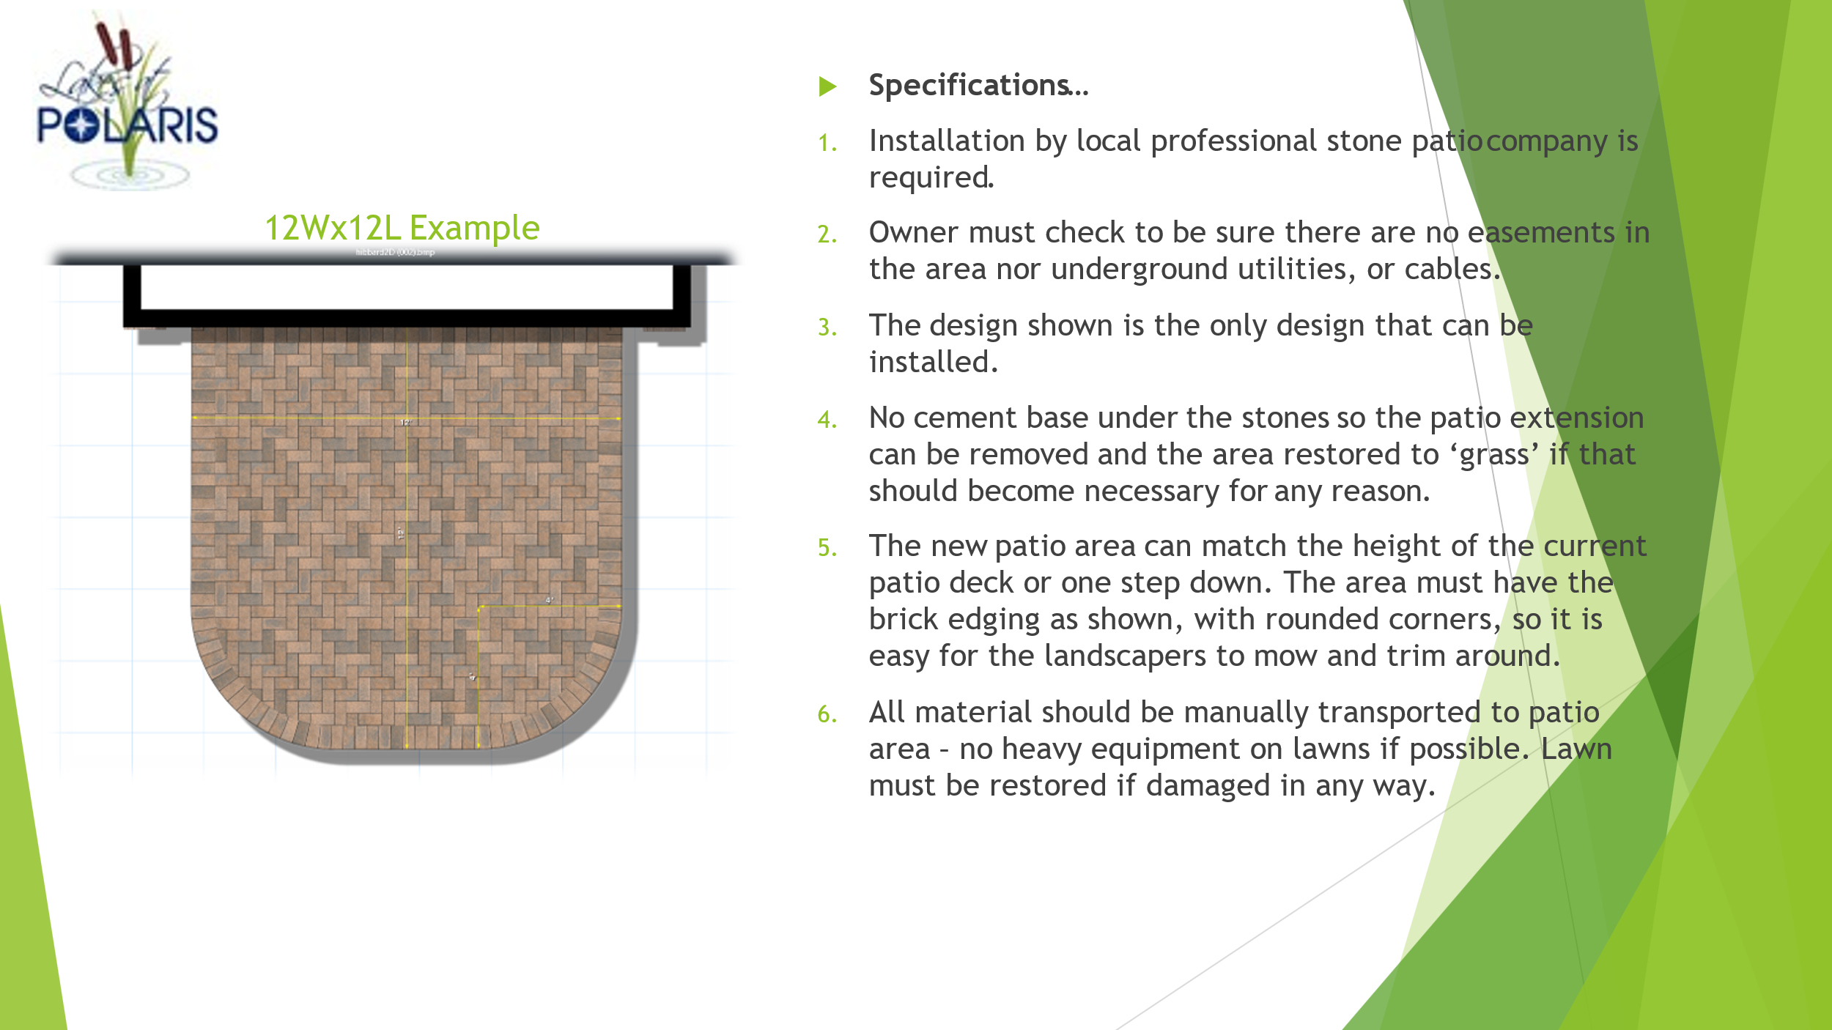

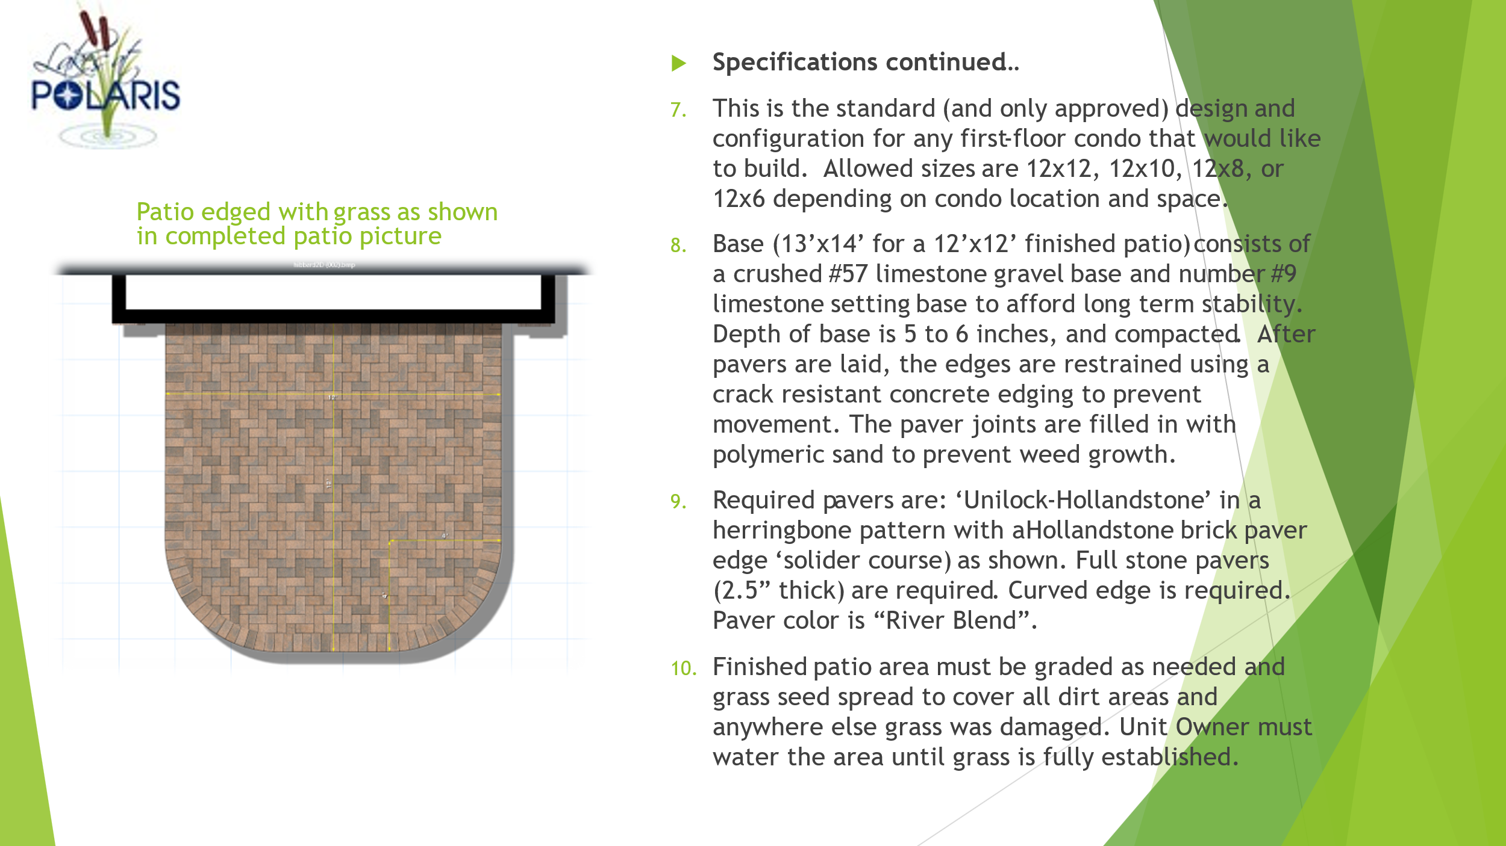
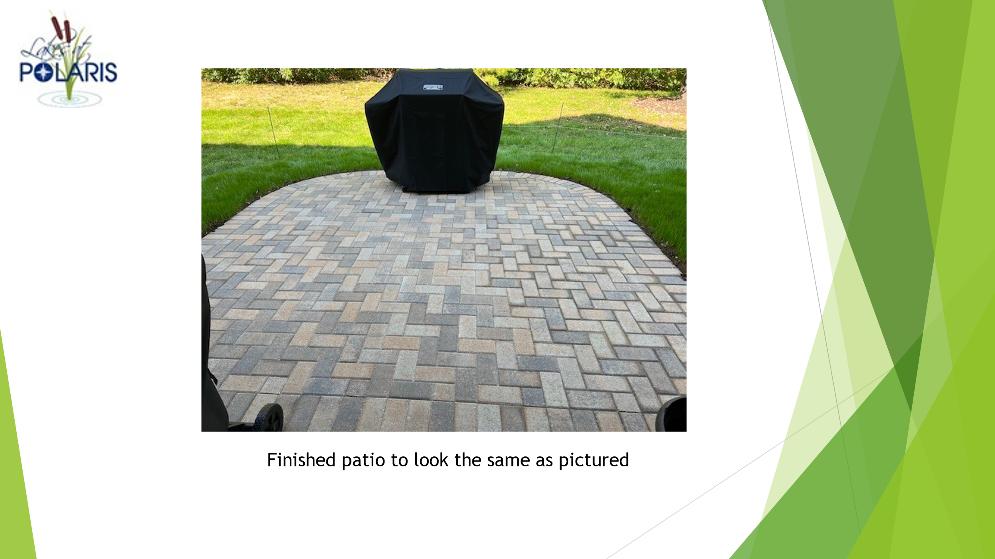

Submit your Request for Alteration similar to this one: (Blank Request on Page 5)
Request for Alteration Example
*Name: | Unit Owner
*Phone: | Xxx xxx xxxx
*Email: | unitowner@email.com
*Unit’s Address: | ZZZZ street
TYPE OF IMPROVEMENT/Alteration REQUESTED:
*Brief Description: | Add custom stone patio extension
Describe alteration: Explain and add drawings/pictures/etc. as needed
*What do you want to do?
We want to add a stone patio for entertaining and relaxing to our first-floor condo. See picture and specifications attached along with the installation company doing the work.
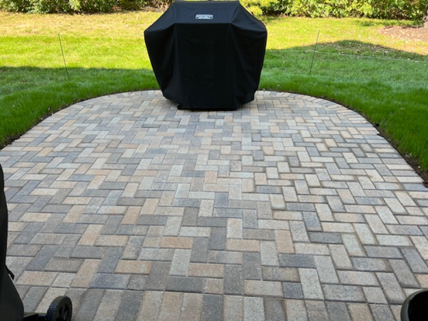

Type into the form or print and write in your plan. Add additional pages and documents as needed.
*Planned Start Date: | June 1, 2025
*Planned End Date: | June 4, 2025
Please check your Rules and Regulations for specifics pertaining to your community and note that all improvements must occur within your Limited Common Area.
*Signature of Unit Owner: | Unit Owner 1
*Signature of Unit Owner: | Unit Owner 2

Request for Alteration
*Name:
*Phone:
*Email:
*Unit’s Address:
TYPE OF IMPROVEMENT/Alteration REQUESTED:
*Brief Description: | Add custom stone patio extension per required specifications
Describe alteration: Explain and add drawings/pictures/etc. as needed
*What do you want to do?
We want to add a stone patio for entertaining and relaxing to our first-floor condo. See picture and specifications attached along with the installation company doing the work.
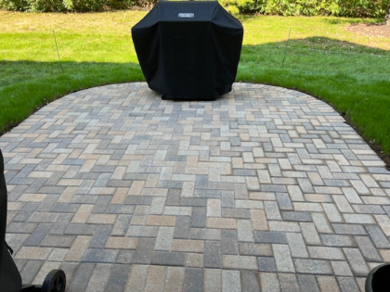
*The completed patio size is: (check one)
- 12 feet by 12 feet ___________
- 12 feet by 10 feet ___________
- 12 feet by 8 feet ____________
- 12 feet by 6 feet ____________

Type into the form or print and write in your plan. Add additional pages and documents as needed.
*Planned Start Date:
*Planned End Date:
Please check your Rules and Regulations for specifics pertaining to your community and note that all improvements must occur within your Limited Common Area.
*Printed Name of Owner:
*Signature of Unit Owner:
*Printed Name of Owner:
*Signature of Unit Owner:

*Required Entry by Owner(s)
Submit this form with Request for Alteration for a patio extension, if approved these documents will be filed and associated with the Condominium Unit listed:
Binding Agreement by Owner(s) requesting the installation of a patio extension to a first-floor Condo Unit at Lakes at Polaris Condominium Community.
*Required Entry by Owner(s)
*Name:
*Phone:
*Email:
*Unit’s Address:

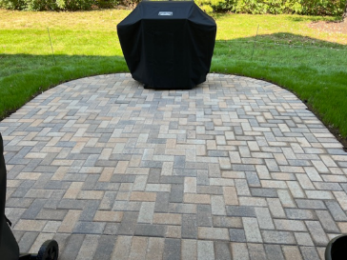
- We are adding a stone patio (if approved) for entertaining and relaxing to our first-floor condo. Per the picture and specifications approved by the LAP Condominium Board. Only the four sizes shown are permitted.
*The completed patio size is: (check one)
- 12 feet by 12 feet ___________
- 12 feet by 10 feet ___________
- 12 feet by 8 feet ____________
- 12 feet by 6 feet ____________

- Is will be exactly as shown in the picture: (size may be different). *Initials: ________
- The patio will be installed by a professional stone mason company per the required specifications. *Initials: __________
- It will be constructed as a ‘temporary’ structure. * Initials: _________
- When we sell the Condominium Unit the patio will be removed and the Common Element restored to original (soil and grass), if requested by the buyer. *Initials: _________
- We will maintain the patio to the same standards as the rest of the Lakes at Polaris. *Initials: _____
- We agree that If the Unit is sold and the new owner wants to keep the patio the selling documents will stipulate that the patio is included in the sale and the new owner(s) will maintain (or remove) the patio to the same standards as the rest of the community. Failure to include this statement in the sales documents is a violation of the Lakes at Polaris Condominium Association LLC rules and regulations. It is subject to legal action by the LAP Condominium Association to the previous owner and the new owner of the Condo Unit listed in the address above. *Initials: _________
*Printed Name of Owner:
*Signature of Unit Owner:
*Printed Name of Owner:
*Signature of Unit Owner:

